n these days almost every college is conducting technical fests where we can gain some knowledge by participating. College, which is conducting fest, will invite so many colleges for the competition. This project is the organizer for event management in a college. This provides college management to schedule events online and assign student volunteers for an event. Event Managers can upload information related to the event in the form of audio, video files. The students and participants can view these files online and download.

Event organizers create schedules for events using well-developed web interface and assign student volunteers at the time of schedule creation. The students register with the site and some of them register as volunteers. Only event organizers and volunteers can upload event content to the site.

College Fest Organizer can be extended to organize the events conducted in a city so that this will be an online portal for any type of event conducted in a city.

**Functionalities:**

Security Module

Event Organizer Module

File Management Module

**1 .INTRODUCTION**

The purpose of College Fest Organizer is to provide an interface for the committee organizing a fest in the college to select volunteers and assign them to various events and also to upload and share various files either audio/video related to the events with the volunteers. The volunteers can upload and download the files from the server. Event organizers create schedules for events.

The scope of the project is that it can be used by any college to automate the functionalities of organizing a fest; it targets the students who want to volunteer and share their ideas..

**1.1 EXISTING SYSTEM**

Fest is organized in almost all the colleges but all the work is done manually. The events

are decided upon and then students are asked whether they will volunteer or not then all

the details are maintained in files. Many colleges have websites for fest that they organize

in their colleges but this website is used for displaying the various events details that are

going to be conducted in those colleges for informing the other college students.

**1.2 PROPOSED SYSTEM**

The proposed system aims at providing the students and organizers a common platform to share files related to the events. This system allows students who want to volunteer to register with the application and view the various events that are to be conducted. The organizers can also register and post the event detail and they can even select volunteers for the event. The organizers can also upload and download files related to the events.

**1.3 PROJECT DESCRIPTION**

The volunteers and the event organizers have to register to the website to use this website. The event organizers can post the events to be held on the site which can be viewed by all. The Organizers can assign students to various events and upload files related to various events. The volunteers will have access to the uploaded files and they can also upload files if any.

This project acts as an event management tool in a college. The various activities that can be performed are listed below

1. The volunteers can view the events that are to be organized.
2. The volunteer s can see to which events they are assigned.
3. The volunteers can upload files for events.
4. The event organizer can post events,.
5. The event organizer can update the events.

**2 .SYSTEM REQUIREMENTS**

**2.1 HARDWARE AND SOFTWARE REQUIREMENTS**

**Hard Ware Requirements**

* + - * + Processor:: Pentium-III (or) Higher
        + Ram:: 64MB (or) Higher
        + Cache:: 512MB

**Software Requirements**

* + - Tools:: Micro Soft Front
    - Operating System:: WindowsNT/2000
    - Server Side:: JSP with Tomcat Server
    - Client Side:: HTML ,JavaScript
    - Services:: JDBC
    - Database:: My SQL
    - Integrated Development Environment:ecllipse

# 2.2 MODULE DESCRIPTION (SYSTEM MODULES)

1. Security Module
2. Event Organizer Module
3. File Management Module

**SECURITY MODULE**

This module provides the authentication for the users. This module contains the registration page, login page .In this module the user is provided with a username and password.

This is used to have access to the uploaded files .If the user is event organizer then he can add new events and update them where as a volunteer has only access to the contents uploaded. So this module gives privileges depending on the user type and avoids access of unauthenticated users

**EVENT ORGANIZER MODULE**

In this module, the event organizer can post a new event and furnish various details related to that event and assign volunteers. The Event Organizer can also update or modify details related to the posted event. The can upload files related to events and can also play and download them.

**FILE MANAGEMENT MODULE**

In this module the user is allowed to upload contents which can be documents or video files. In this module the user can download the files and also play the files online. The files are saved on the folder on the server.

**3.SYSTEM DESIGN**

**SYSTEM DESIGN**

System design is transition from a user oriented document to programmers or data base personnel. It provides the understanding and procedural details necessary for implementing the system recommended in the feasibility study. Designing goes through logical and physical stages of development, logical design reviews the present physical system, prepare input and output specification, details of implementation plan and prepare a logical design walkthrough.

The database tables are designed by analyzing functions involved in the system and format of the fields is also designed. The fields in the database tables should define their role in the system.

**SOFTWARE DESIGN**

In designing the software following principles are followed:

1. **Modularity and partitioning**: software is designed such that, each system should consists of hierarchy of modules and serve to partition into separate function.

2. **Coupling:** modules should have little dependence on other modules of a system.

3. **Cohesion:** modules should carry out in a single processing function.

4. **Shared use:** avoid duplication by allowing a single module is called by other that need the function it provides

**5. OUTPUT SCREENS**

Home Page

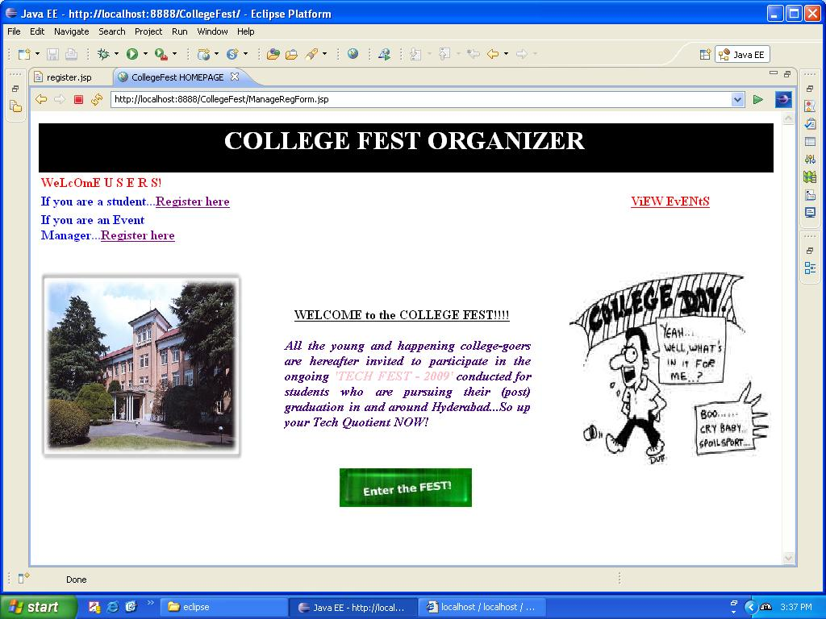

Student’s Registration Form

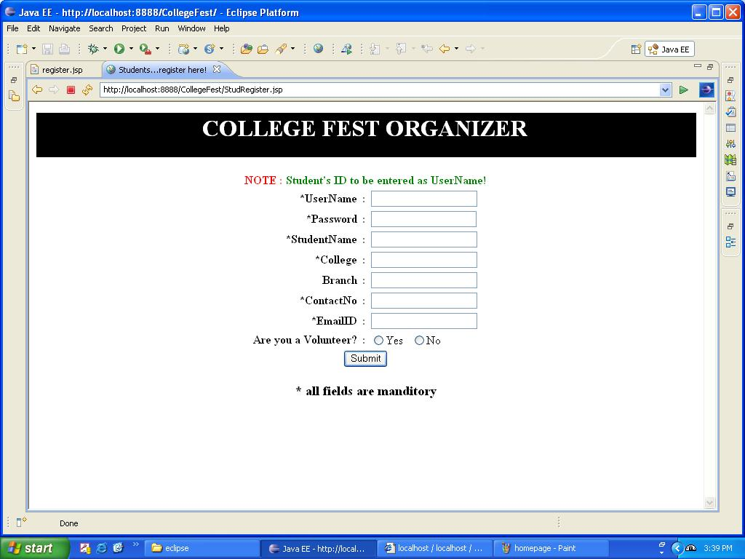

Organizer’s Registration

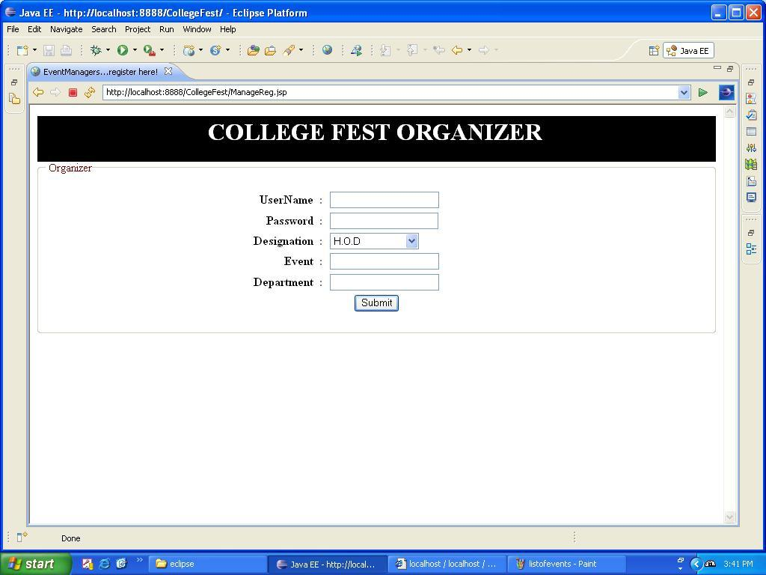

Organizer’s Homepage

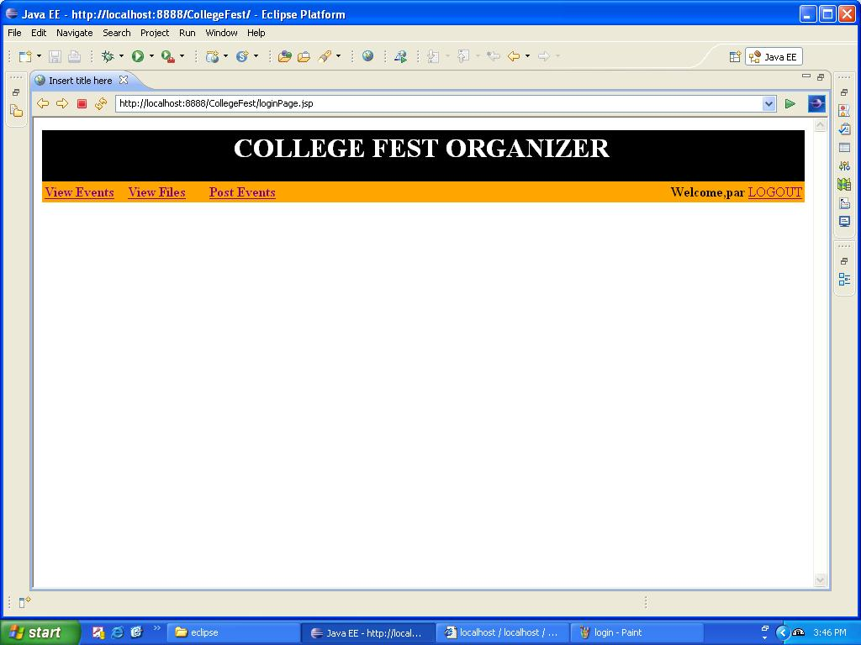

Post an event

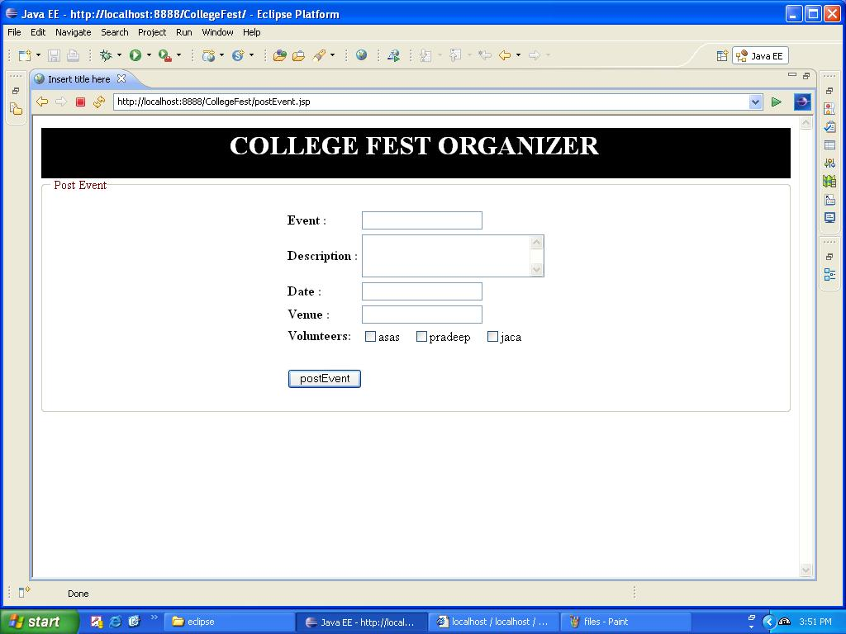

Update Event Details

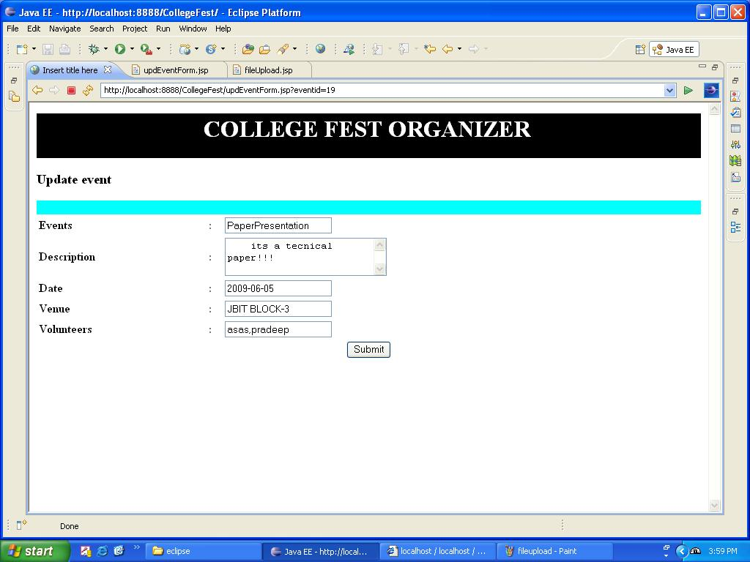

Upload Files related to event

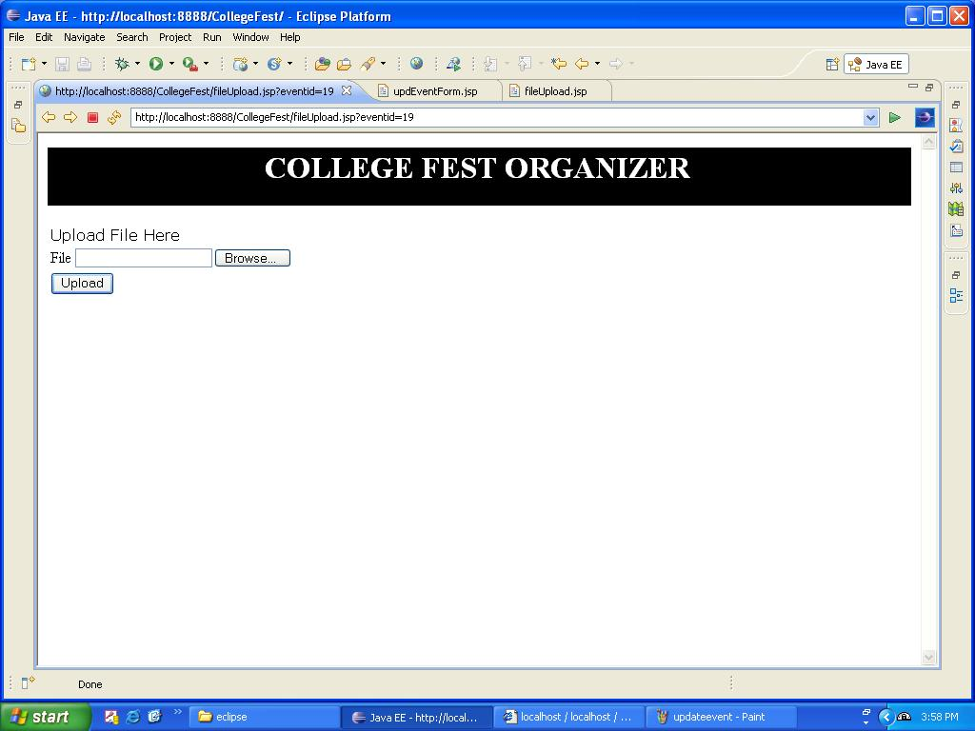

View Files

